

project report

Quiz Application



Team members :

Ahsan ali , Sardar Ahmed, Zabir malik

Student Of Class: BSCS - II

Table of Contents

ABSTRACT 2

INTRODUCTION 2

DEVELOPMENT TOOLS 3

FEATURES 3

SNAPSHOTS 3

# ABSTRACT

Instead of the regular pen-paper examinations held by various institutions, one can make use of the Quiz Portal. Quiz Portal makes education fun and easier. This system is useful for conducting multiple choice questions. examinations, which can be conducted regularly or for surprise tests as well. It provides immediate results. saving time. The administrator will have the privilege to show the result on the last screen when the student has done his quiz, and the teacher also changes the question from the backend code and modify the test the papers, and their. questions. The candidate can enter the name, log in and see the rule of taking the quiz and give the test and can see the result as well.

It would provide easy access to the user. Each category of questions is to be maintained in the backend code where the teacher add question as he /she wants to add. This would form the backend of the project. The front end of the project is planned to be implemented using the Java language on the JAVA NetBeans IDE platform. This platform has a lot of advantages, from being able to create a simple interface with certain components to connect the database to it directly.

Keywords: candidate, JAVA NetBeans, Java Quiz Application, Java Gui.

# INTRODUCTION

The Online Quiz is a sort of Desktop application coded with java language for the students to emerge for an online examination efficiently and there is no failure of time to verify the paper. The main intention of the Online Quiz is to successfully approximate the applicant entirely via a computerized structure which besides preserving time offers swifter outcomes. Normally, pupils are provided with paper, pen, etc. for taking the examination but the Online Quiz does not necessitate all these. This application is primarily developed in NetBeans, which is Desktop IDE software that can be engaged to build up a wonderful Application or Software. The benefit of this software is that it is at no cost as well as inexpensive.

The QUIZ PORTAL is an application that helps in Effectively taking tests and there is no waste of time checking the paper. The main objective of this project is to efficiently evaluate the candidate’s performance thoroughly through a completely automated system that not only saves a lot of precious time but also generates the result way quicker than the manual system. For students, the biggest advantage is that they get to give papers according to their convenience, and time and wastage

of materials like pen, paper, etc. are thoroughly reduced. This can be used in educational institutions as well as in the corporate world. There is no requirement for the presence of an invigilator during the exam session.

# DEVELOPMENT TOOLS

* We Make our Desktop Application With Help IDEs NetBeans, IntelliJ
* We Make our Quiz Application With the Java Language, Graphics Library, OOP Concepts
* We add the Html Code For Adding Question

# FEATURES

* Candidate / Student direct Enter The Name For Username.
* User Friendly
* Get Result On Time (when test is over automatically user get their result)

# SNAPSHOTS

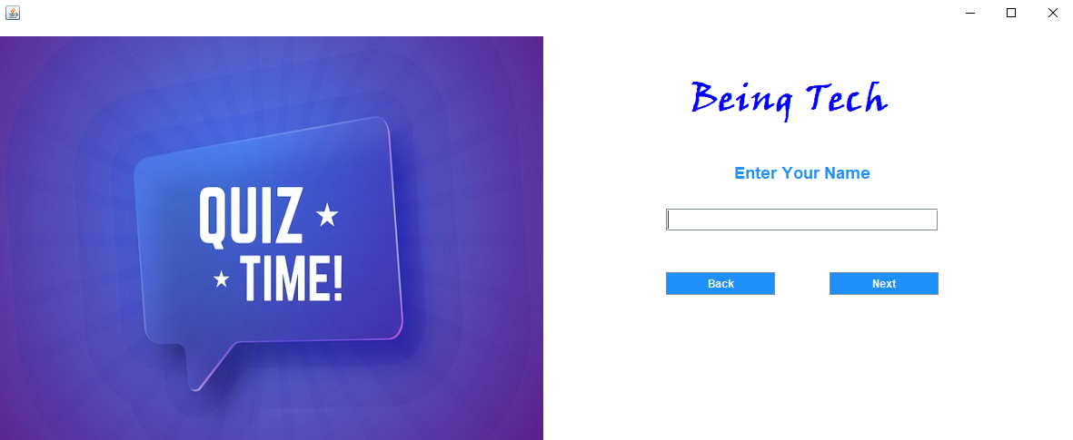 STEP 01: When user enter in the Application

Here is user enter the name

STEP 02

For Exit the Applictaion

For Proceeds the Quiz

STEP 02 : Here is Simple We apply the rules and regulation of quiz for user when he/she attempt the quiz

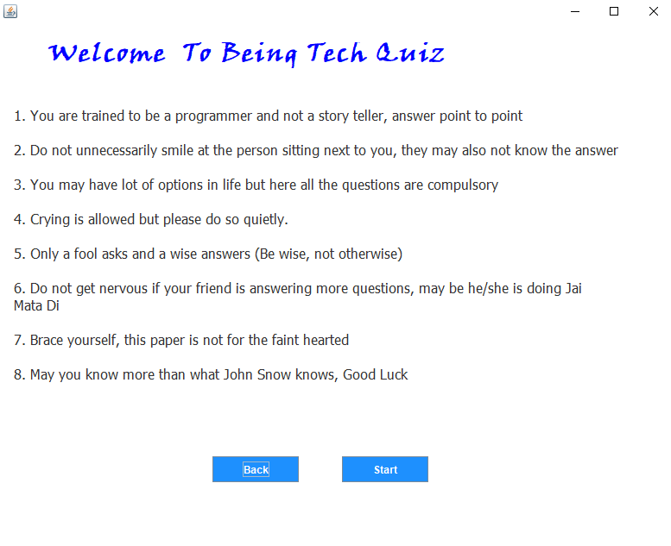



When User Click the start btn the quiz will start automatically

When user Click the Back the user land on previous login page



STEP 03 : GUI of Quiz application when user take the quiz

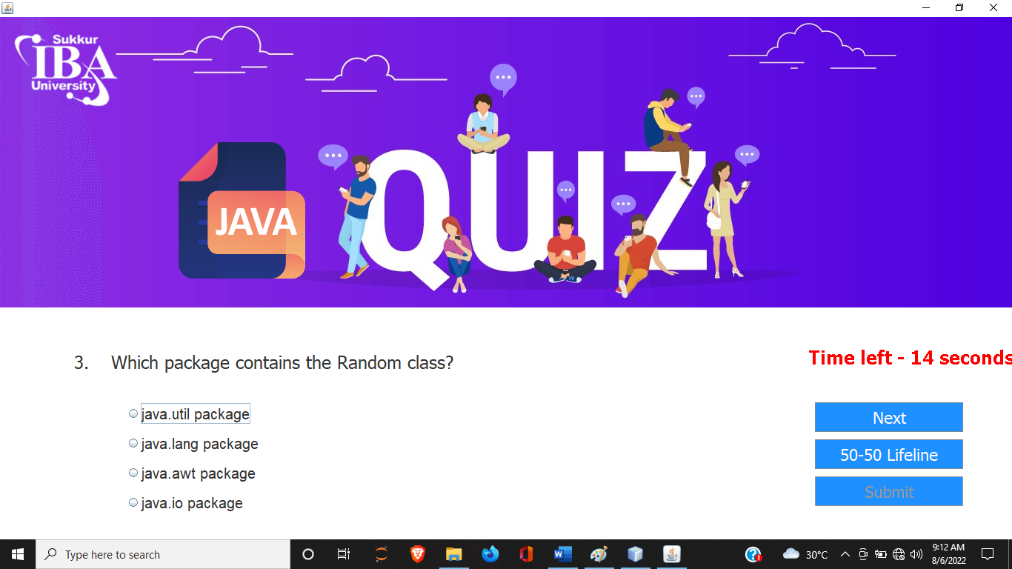

Tik Tok Time Watch per Qno take 30 sec



For Move and Change The Qno’s

When User use Lifeline the 1 Question have 2 options the wrong answers will remove from the question

**When User Attempt all the questions from quiz automatically the Submit appears and user submit there answers and get the result**

STEP 04 : Get The Result Of attempted Questions:

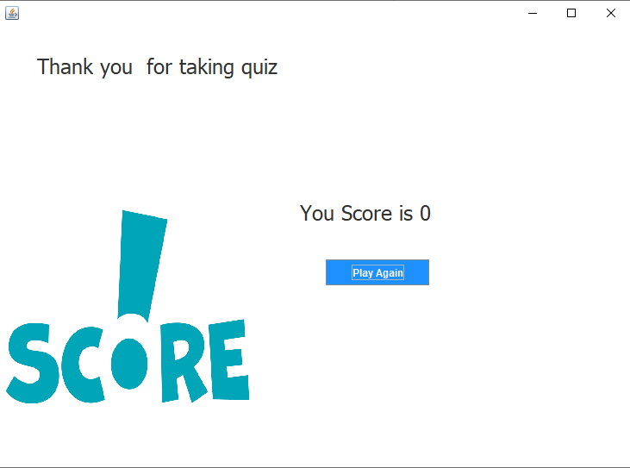

**When User Get the result he/she wants to play quiz again then click that btn the user land on login page**



**When User Attempt all questions and get result in the end of quiz**

# LIBARIES USE IN PROJECT

* import java.awt.event.ActionListener;
* import javax.swing.Action;
* import java.awt.*;
* import java.awt.event.*;
* import javax.swing.*;
* paint(Graphics g) -- > For time decresing

# 